|  |  |  |
| --- | --- | --- |
| Web Design. | March 12  2016 | |
| **Simple Programs:** | | Unit: ICAWEB505A Unit: ICAWEB506A |

Peter Petersen – 4101833111  
17 Indigo Crescent - Annandale  
Townsville 4814.  
Mobile-0451919894

Input: Develop Complex web page layouts.  
 Develop Complex cascading stylesheets.

Table of Contents

Table of figures 2

Assesment Description 3

Project Description 5

Executive Summary 7

Introduction 7

Task 1 - Review site requirements 8

For this task you will need to review the client requirements from the design brief. 8

Identify the main sections of the page for layout. 8

Create an appropriate file / folder structure for the site 9

Task 2 - Site Structure 10

Header Area 11

Main Menu / Navigation 11

Main Page/Home 11

Sidebar / Right column 12

Footer Section 12

Style Guide 12

Link Style 12

Advanced Css Techniques Used 13

Task 3 - Test and validate the site. 14

Technical Specification checklist 17

Site Validation 18

Accessibility standards 21

Tablet & Mobile Screenshots 22

Recommendations 24

## Table of figures

Figure 1 Client Page Layout 8

Figure 2 Site folder structure 9

Figure 3 Style Guide 11

Figure 4 Link Styles 11

|  |  |
| --- | --- |
| Assesment Description | **Uncontrolled when printed**  **16/12/2014**  **FM02_21b** |
|  |  |

|  |  |  |  |  |  |  |  |  |  |
| --- | --- | --- | --- | --- | --- | --- | --- | --- | --- |
| **Student Name:** | | | Peter Petersen | | | **Student Number:** | | | 4101833111 |
| **Unit Code/s & Name/s:** | | | ICAWEB505A: Develop Complex web page layouts  ICAWEB506A: Develop complex cascading Stylesheets | | | | | | |
| **Assessment Description:** | | | P1 | | | | | | |
| **Assessment Due Date:** | | | 28 Jan 16 | | **Assessment Received Date:** | | |  | |
| **Student Declaration:** I declare that this assessment is my own work. Any ideas and comments made by other people have been acknowledged as references. I understand that if this statement is found to be false, it will be regarded as misconduct and will be subject to disciplinary action as outlined in the TAFE Queensland Student Rules. I understand that emailing or submitting this assessment electronically confirms my assent to this declaration in lieu of a written signature. | | | | | | | | | |
| **Student Signature:** | |  | | | | **Date: / /** | | | |
| **Assessor Feedback:**  **Student provided with feedback** | | | | | | | | | |
| **Attempt 1 Satisfactory  Not Satisfactory  Date:      /     /** | | | | | | | | | |
| **Attempt 2 Satisfactory  Not Satisfactory  Date:      /     /** | | | | | | | | | |
| **Assessor Name:** |  | | | **Assessor Signature:** | | |  | | |
| **Note to assessor: Please record any adjustment below that has occurred to this assessment e.g. Oral questions were used to support student’s ability to complete tasks identified.** | | | | | | | | | |
|  | | | | | | | | | |
| **Disclaimer:** TAFE Queensland North (TQN) is collecting the information on this form for assessment purposes. Only authorised Departmental officers have access to this information. Your personal information will not be disclosed to any other third party without your consent, unless authorised or required by law, in accordance with the Information Privacy Act 2009. | | | | | | | | | |

|  |  |
| --- | --- |
| **Instructions to Student:** | **Time allowed:** This assessment is to be completed over the semester.  **Materials and equipment to be supplied by the Student:**   * Access to a PC, Web Authoring Tools, web server and hosting.   **General Instructions:**   * You will need access to the AllStyles Design Brief * You have 3 tasks to complete. * You will need to answer **all** questions correctly * Keep a copy of all assessments as you will be required, to upload them to Github and advise your teacher for marking.   NOTE: If you are not successful on your first attempt, you will be given comments and a further one week to rectify the changes.  You will need to re-submit your corrections for remarking. If you are unsuccessful on your second attempt, you will be required to re-enrol in this unit. |
| **Instructions to Assessor:** | Please see Instructions to Student above. |
| **Assessment Context and Description: (if required)** | In order to gain competency in ICAWEB505A: Develop Complex web page layouts and ICAWEB506A Develop complex cascading style sheets, successful completion is required of the following assessments items:   * Practical Assessment |
| **Note to Student:** | An Assessment Matrix is available from your teacher upon request. The matrix shows how the knowledge and skills that you are being asked to demonstrate align to the Elements, Performance Criteria, Critical Aspects, Required Skills and Required Knowledge components of each Unit of Competency. |

# Project Description

For this project you need to develop a client website according to the given design brief. The site is to be laid out, styled and formatted using advanced CSS.

You will need to create a new folder called '**complex_webpages_adv_css_youname**' and save all files in this folder. You should create sub folders as necessary.

Task 1 - Review site requirements

For this task you will need to review the client requirements from the design brief. You will need to document the following to be included in your report:

1. Identify the main sections of the page for layout
2. Create an appropriate file / folder structure for the site
3. Develop a naming convention for files

Task 2 - Develop the site

For this task you need to develop the client site according to the requirements. You should:

1. Create an external cascading style sheet according to the design specifications and style guide to be linked to the pages. **Note:** You may need to adjust your styles as you develop the pages.
2. Ensure that you CSS file is adequately commented. It should clearly define: each of the main sections of your page and what each style or group of styles relate to.
3. Develop a responsive website for both **desktop**, **tablet** and **mobile** browsers ensuring that your CSS is applied to all pages within the site.

* Ensure there is sufficient content on each page to fully test the site. This will usually mean several paragraphs of content per page as well as images.
* Your CSS is to include advanced CSS techniques including:
  + Media queries-
  + Animations-
  + Child and direct descendant selectors-
  + Z-index layering
  + Transparency
  + Element sizing for fluid design.

1. Write a brief report on how you have used CSS to achieve each of the requirements for the website such as imagemaps, text styles, navigation and layout.

Task 3 - Test and validate the site

For this task you are required to test the website and rectify any inconsistencies or issues with the site. You should develop a checklist of all test criteria that you need to test against. The testing needs to be documented in a report that covers the following points:

1. Test the website across a number of different browsers to ensure consistency of presentation
2. Ensure the site meets each of the technical specification criteria
3. Ensure the site meets each of the style guide criteria
4. Validate your site, including your CSS against industry standards (W3C) and
5. Test the website to ensure it meets accessibility standards including visual impairment.
6. Identify any issues with the site and document your rectifications
7. Re-test the site to ensure the rectifications have been properly implemented.

You should add the following to your report for this task that details the following:

* The results of your initial testing (your completed checklist will be sufficient)
* Your recommendations and rectifications to issues
* The results of your testing after you have implemented your rectifications
* 2 x recommendations for additional or changes to design features

Project Resources

Resources needed to complete this project.

Design Brief - This document describes the requirements of the project   
located on the Diploma Shared Drive

Wireframe -Obtained from Design Brief.

Site Structure – As required.

Logos – Obtained from Design Brief.

Imagemap image - Source image obtained from Design Brief.

You will need to submit

The following should be included in your Github repo (please ensure that there are no additional files):

* Your completed website, after testing and required corrections. (Tasks 1, 2 & 3)
* Your report on the implementation of CSS: labelled Task 2 Report (Task 2)
* Your testing report: labelled Task 3 Report (Task 3)

**End of assessment**

# Executive Summary

This report has been developed to document the design requirements for the development of a web presence for AllStyle Homes. The report details the layout of pages, formatting of content, text and standards and that meet the requirements as requested by the client.

AllStyle Homes is a family owned business operated by Alex and Sheree Knox. Alex has spent over 25 years in the building industry and together, with Sheree has operated AllStyle Homes for the past 15 years with a hands-on approach. Sheree is a qualified interior designer as well as the business/finance manager.

AllStyle Homes want to develop a website that will showcase their business and designs to new and existing customers whilst enabling new and returning customers to view their designs and other services they offer which in turn will lead to increased sales.

A well designed website will provide the opportunity for AllStyle Homes to reach a broader market, give increased control of their marketing and raise their profile as a contemporary, innovative and modern company.

Computer Solutions has been engaged to develop a website for AllStyle Homes. Whilst AllStyle Homes’ competitors continue to make inroads with their web presence there is evidence that AllStyle Homes business will suffer if they do not embark on this marketing tool.

A well designed website will provide the opportunity for AllStyle to reach a broader market, give increased control of their marketing and raise their profile as a contemporary, innovative and modern company.

# Introduction

The purpose of this report is to document the business and user needs for the development of a web presence/ website for AllStyle Homes. The report details the design requirements as developed between Computer Solutions and AllStyle Homes.

## Task 1 - Review site requirements

### For this task you will need to review the client requirements from the design brief.

We were given a design brief to outline the page layout and content spacing for the site, as well as stating the margins, colors, font styles & sizes, image sizes and padding for the website.

Each page will contain a Div called “wrapper” which contains the entire page content from the “header” the “navigational bar”, “main content”, “sidebar area” and the “footer”. The wrapper will have a solid width of 800 pixels.

Identify the main sections of the page for layout.  
As shown below the page is divided into six sections with spacing of 10px between each Div. and a brief explanation of each div is given to get a starting point.

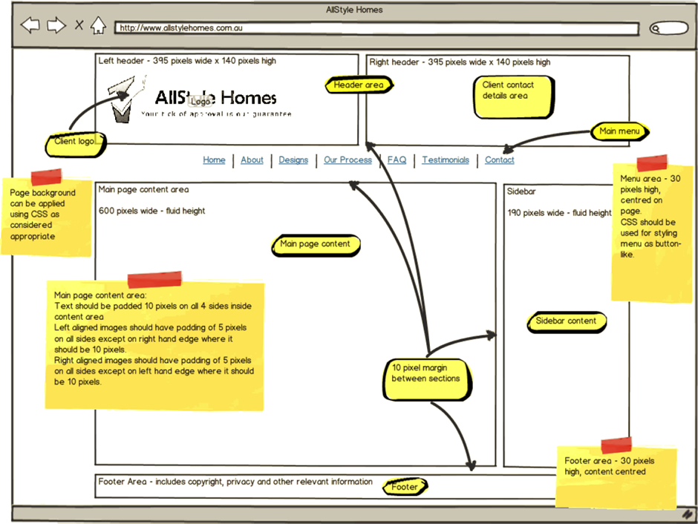   
Figure Client Page Layout

Create an appropriate file / folder structure for the site.

Figure Site folder structure



Website Folder Structure

Index.html



complex_webpages_adv_css_peter



php

images

pages

css

js

##### Develop a naming convention for files.

* Folder naming convention - Folders should be named to represent the contents of the folder, for example: images, pages and all in lowercase up to 20 characters with no spaces, and underscores for separation.
* File naming convention - All lowercase alphanumeric up to 20 characters.  
  Three letter file type extensions, No spaces, and use underscores for separation.  
  **jpg** - Stands for Joint Photographic Experts Group, JPG files, are a common file format for digital photos and other digital graphics.   
  **png** -Stands for Portable Network Graphics, is a file format for image compression that, in time, is expected to replace the Graphics Interchange Format (GIF) that is widely used on today's Internet.  
  **css -** Stands for "Cascading Style Sheet." Cascading style sheets are used to format the layout of web pages. They can be used to define text styles, table sizes, and other aspects of Web pages that previously could only be defined in a page's HTML.

##### Folder Structure

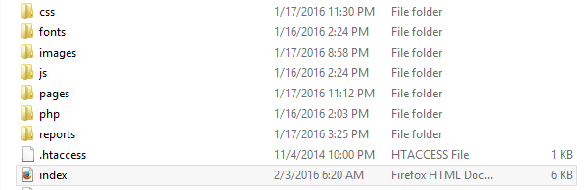

Figure Folder Structure

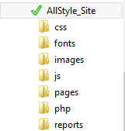

Figure 4 Image displays the hosting folder containing the folders that are relevant and required to construct the web site.

The Figure 3 image is expanded to reveal the necessary components to complete the website in preparation to upload to a server.

Figure Site Folders

## Task 2 - Site Structure

The section titled Client page layout (Figure 1) gives an overview of the basic site structure and navigation, In addition it also contains information regarding layout and formatting of content blocks of the page, and however it may be necessary to add additional pages to the overall layout of the site as the site progresses and develops.

The web page layouts are designed using Div tags, with individual classes assigned to them.

The “Wrapper” is the element that encloses one or more elements in the html markup.

All the elements inside the wrapper are then given specific classes which are styled in the “cascading style sheet” otherwise known simply as CSS.

Header Area  
The Header section consists of three individual Div.’s called Header- Left header and Right header. The div named “Header “is the main section and acts as a container (width) 798 pixels for the other two divs. The height is set at 140 pixels as per design brief.

Left Header {49.5%} - Contains the company/Website Logo. The company Logo image is floated to the left hand side.  
Right Header {49.5%} – Contains the Company/Website Client details. By setting both Header width sizes to {49.5%} this allows for the 10 pixel margin required by the client with background color of: #f6f6f6.

### Main Menu / Navigation

All navigational buttons should contain links to the other pages of the website.  
Menu Bar has dimensions of 30 pixels in height and 798px in width. This is a simple navigation bar that uses several classes to give it form and shape and allows for a better overall finish of the navigation area. The design was formed by using a div tag with id name of “Navbar” and placing all the menu links in an unordered list named “nav” which contain the anchor links to the pages. I have left the “Home” button active with the distinct color of black to give the menu bar a distinctive look of its own. The color to the navigation bar itself is orange (#f7760c), the navigation bars hover color is a lighter orange (#7760c), this giving it overall depth in hover mode.

### Main Page/Home

This area or section contains the main content pertaining to the respective web page such as general information about the business. This Div is called ”home_page” and is the entire area between the navigation bar and the footer acting as the “wrapper” for this area, and has a width of 100% with margins top & bottom of 10pixels, also a solid border of 2pixels with the color property (#660033) assigned. The two child Divs in this area are then“main_content” and “sidebar1”

The div “main_content” holds the page specific text and images; this area will hold the text which tells the page user about the company and what their goals and their services offered. The dimensions for this area are as follows width of 74% it is floated to the left and has padding of 10pixels to the right and bottom sides; with a margin of 10pixels both top and bottom.

### Sidebar / Right column

The right column Div named “sidebar1” will contain sponsor links, advertisements or images in relation to the building industry and set with 23% width with minimum height of 725 pixels. The content has been set as centered with the 10pixels margin between the two Divs. It is floated to the left to align it with the right side of the “main_content” Div.

### Footer Section

Footer section is set at 30 pixels in height with a top margin of 10pixels and all content is centered, the footer section contains Links to other pages such as Privacy Policy Statement, Terms & conditions, Sitemap as well as the Copyright symbol. The clear both “element” has been used in order for the footer not to be affected by changes made to either “main_content” or “sidebar1”.

## Style Guide

Figure Style Guide

|  |  |
| --- | --- |
| Colors | Text Style |
| True Orange #e86600 | Default Font Family Verdana, but can degrade to Arial, Helvetica, sans-serif |
| Strong Red - #b40c00 | Typing text – Font 20pt |
| Strong Red - #b40c00 | Heading2 – 15pt Bald |
| Black - #000000 | Paragraph text – Font 12pt |

## Link Style

The footer area should also contain a text menu (centered within the footer area) with each item separated by the | pipe character and with the following link specifications.

Figure Link Styles

|  |  |  |
| --- | --- | --- |
| A:Link | Font size : 12pt | Font color : #b40c00 |
| A:Visited | Font size : 12pt | Font color : #e86600 |
| A:Hover | Font size : 12pt / underline | Font color : #b40c00 |
| A:Active | Font size : 12pt | Font color : #e86600 |

## Advanced Css Techniques Used

Figure Image map



The first thing needed to be done is to create the div that will contain the image to be mapped and the icons will be in a list and every icon will need a class name assigned to it. The image’s property must be set to Relative position thus allowing the icons to be positioned where you want them. To position the icons where you want them we need to assign them individually a value to the Top and Left property of the Link using its class name.

In order to see the text on hover this was styled in CSS. The position property of all the icons were set to absolute. Other properties can also be styled like the width, margin, padding, text-alignment, font-size, border, etc. To hide the text off the screen, I assigned various values of negative pixels to the left side of the image. Now that the text is hidden, we now need to make it appear when the user hovers over the icon images. This can be done by defining the left position and opacity values of 1 to the hover class. The text will then slide across or down when hovered over the individual icons.

## Task 3 - Test and validate the site.

1. Test the website across a number of different browsers to ensure consistency of presentation.

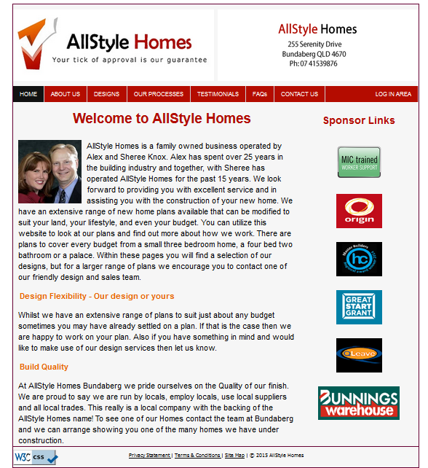

Figure - Firefox Browser

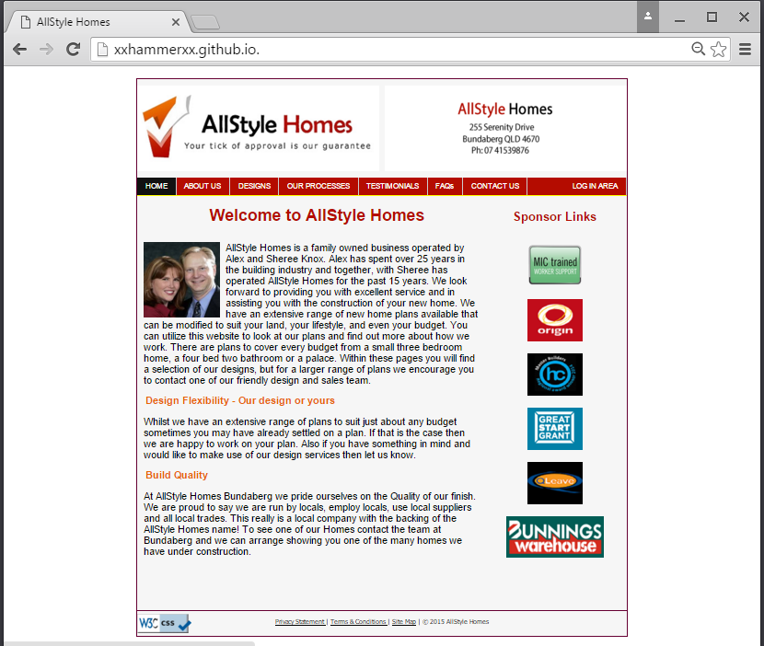

Figure - Chrome Browser

Figure - Internet Explorer Browser

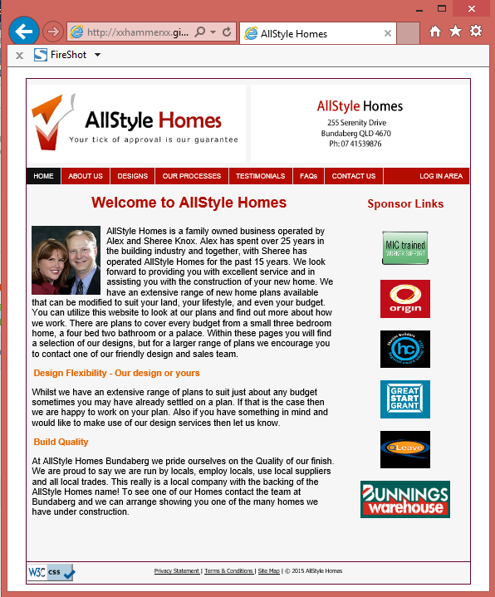

1. Ensure the site meets each of the technical specification criteria.

## Technical Specification checklist

File Naming Convention

All lowercase alphanumeric - Three letter file type extensions - No spaces, an underscore for separation.

<http://webdesign.about.com/od/beginningtutorials/f/html-file-names.htm>

Folder naming convention

Folders should be named to represent the contents of the folder eg: images.  
All lowercase .No spaces, an underscore for separation.

Browser capability

Internet Explorer 8+ - Mozilla Firefox 10+ - Google Chrome 17+

<http://browsershots.org/>

Browser Plug Ins.

No specific browser plug-ins required at this stage.

File Format to be used

Image files should be .gif, .jpg or .png as appropriate

Pages should be .html / .php

Images – Png or Jpg - Index/Pages – Html  
Java script – Js - Cascading style – CSS

Document Formats

All documents should be provided in an accessible format.

Portable Documents – PDF

Page download times

< 10 secs at 256kbps - <http://tools.pingdom.com/fpt/>

Default desktop screen resolution - Desktop – 1024 x 768 pixels

Content accessibility

W3C Content Accessibility Guidelines 2.0

(WCAG 2.0) Level A

W3C Cascading Style Sheets Level 2

Revision 1 (CSS2.1) minimum

<http://www.w3.org/WAI/WCAG20/quickref/>

<http://www.w3.org/TR/CSS21/>

Target Hardware

Ascertain proposed target hardware, desktop and mobile users.

1. Ensure the site meets each of the style guide criteria.

All style guides outlined in the design brief have been met.

1. Validate your site, including your CSS against industry standards (W3C) and (submit these as screen shots)..w3c validation

## Site Validation

Figure Index.html

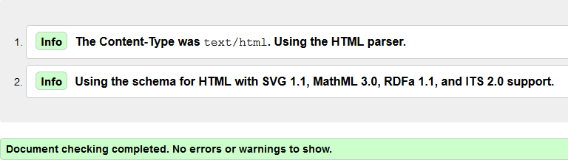

Figure About Page

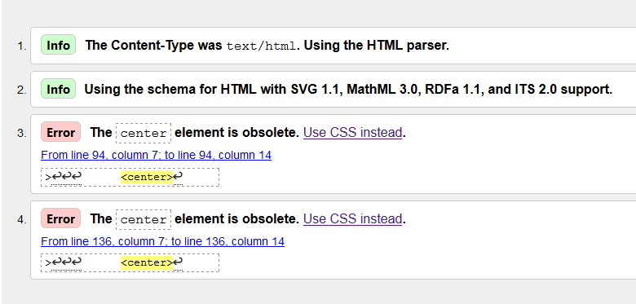

The center element is obsolete issues were rectified by placing the element inside a div and specifying a class.

.center { text-align:center; }

Figure Re validation About page

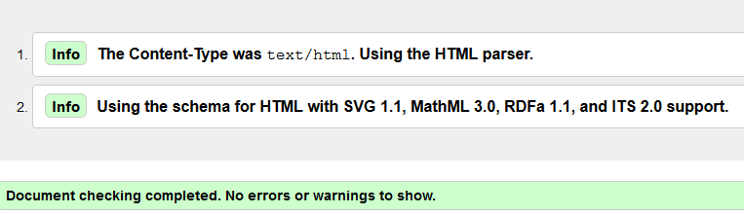

Figure Design Page Validation

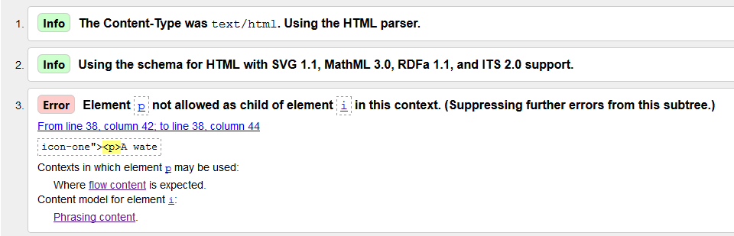

The above error was ignored due to the fact that the validation service could possibly be outdated. In retrospect the design page will be mentioned for redesign in my recommendations for additional changes to be made to the design features.

Figure Our Processes validation

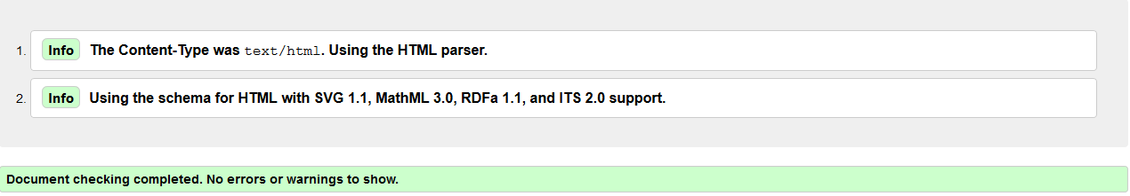

Figure 16 Testimonial Page Validation

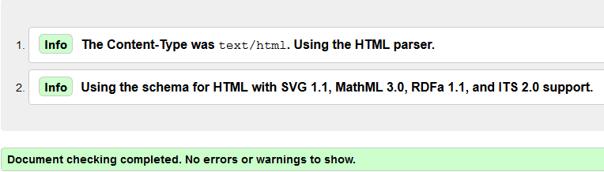

Figure 17 Faqs Page Validation

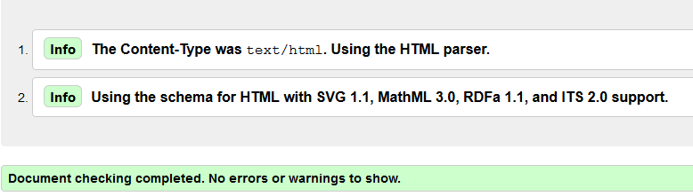

Figure Contact Us Validation

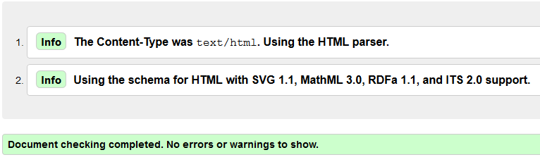

Figure Sitemap Validation

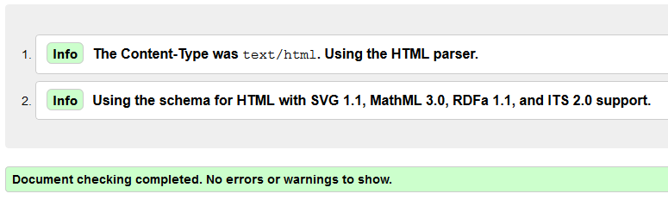

Figure CSS Validation

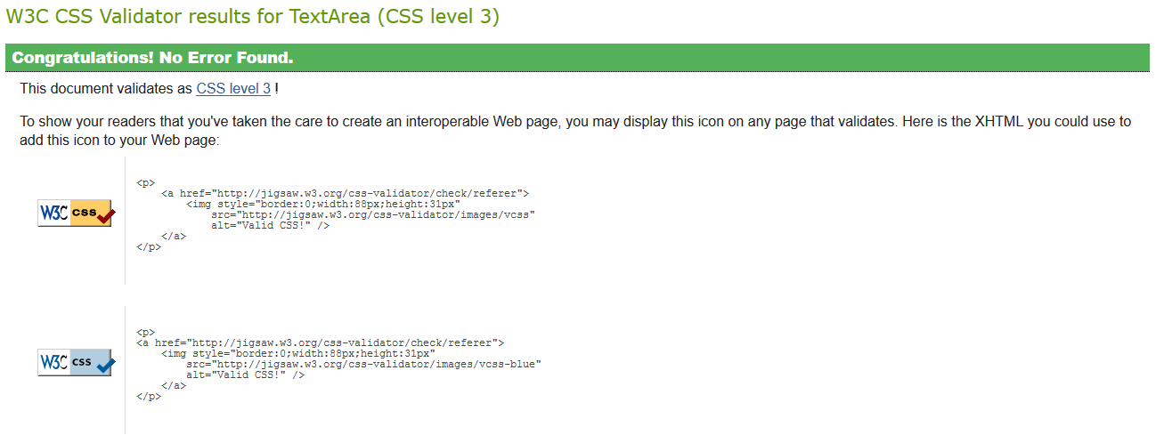

1. Test the website to ensure it meets accessibility standards including visual impairment.

## Accessibility standards

Figure Responsive results

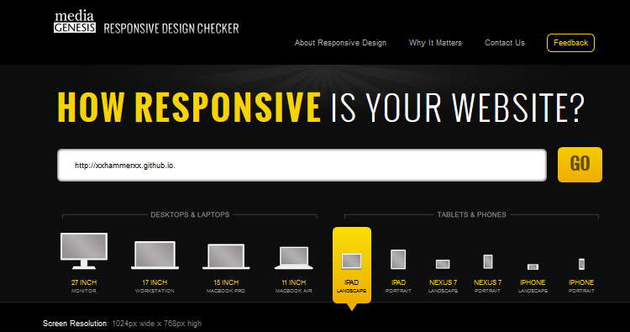

AllStyle Homes website was tested using the online Responsive Design Checker against all ten devices. Results were satisfactory when loading from the github URL <http://responsivedesignchecker.com/xxhammerxx.github.io>.

No scaling restrictions to pages or zooming were enabled.  
No tables were used in the design phase of the website.  
Alternative Tags were used on all images in html markup.

### Tablet & Mobile Screenshots

<link href="../css/media.css" rel="stylesheet" type="text/css">  
@media rule is used to define different style rules for different media types/devices.

* Media queries- Tablet - @media (min-width: 481px) and (max-width: 801px)
* Media queries- & Mobile - @media (max-width: 481px) { }

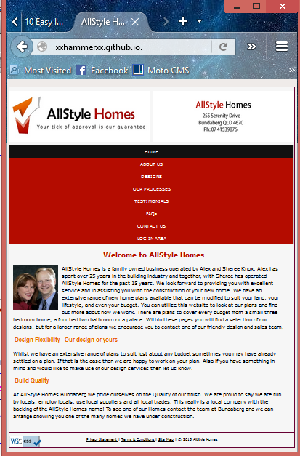  
Figure 22 Tablet size 798px

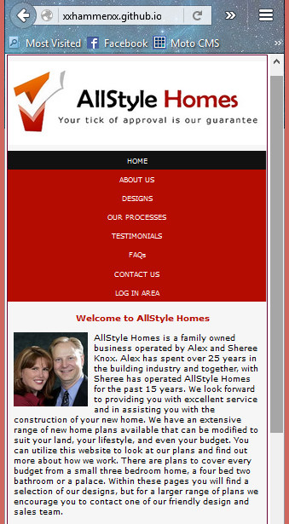

Figure 23 Mobile size 481px

Again A better view can be seen by entering the URL of <http://responsivedesignchecker.com/xxhammerxx.github.io>. Into any browser to see design responsiveness against a variety of devices.

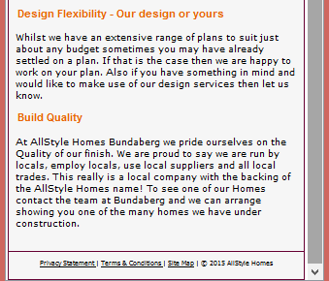

1. Identify any issues with the site and document your rectifications.

All issues were dealt with.

1. Re-test the site to ensure the rectifications have been properly implemented.

Re- testing performed over several stages and satisfactory results obtained.

## Recommendations

I have recommendations for changes to the design features of AllStyle homes web site.

* On the Index / home page html I would remove the side bar / right column so as to have a full width content area. This will then give more area to insert image or images of display homes.
* On the Design page I would remove the Image map and replace it with a full width slide show displaying AllStyle Homes products.